### **Report on the Python MasterClass**

#### **Overview**

From **November 21 to November 27, 2024**, We conducted a **6-day Python masterclass** for students across Udaipur. The sessions aimed to introduce students to the fundamentals of Python programming and guide them through intermediate topics to build a strong programming foundation.

#### **Agenda**

* **Day 1: Thursday, 21 November**
  + *Topics Covered*: Print function, Arithmetic Operators, Order of Operations, Comments
  + *Highlights*: Students were introduced to the basics of Python syntax and key operators.
  + *Photos*: Not available for this session.
* **Day 2: Friday, 22 November**
  + *Topics Covered*: Variables and String Manipulation
  + *Highlights*: Demonstrated practical applications of variables and string operations to create dynamic outputs.
  + *Photos*: Captured moments of student engagement during live coding exercises.

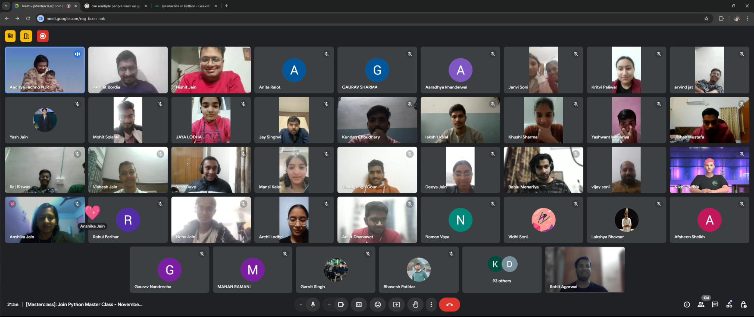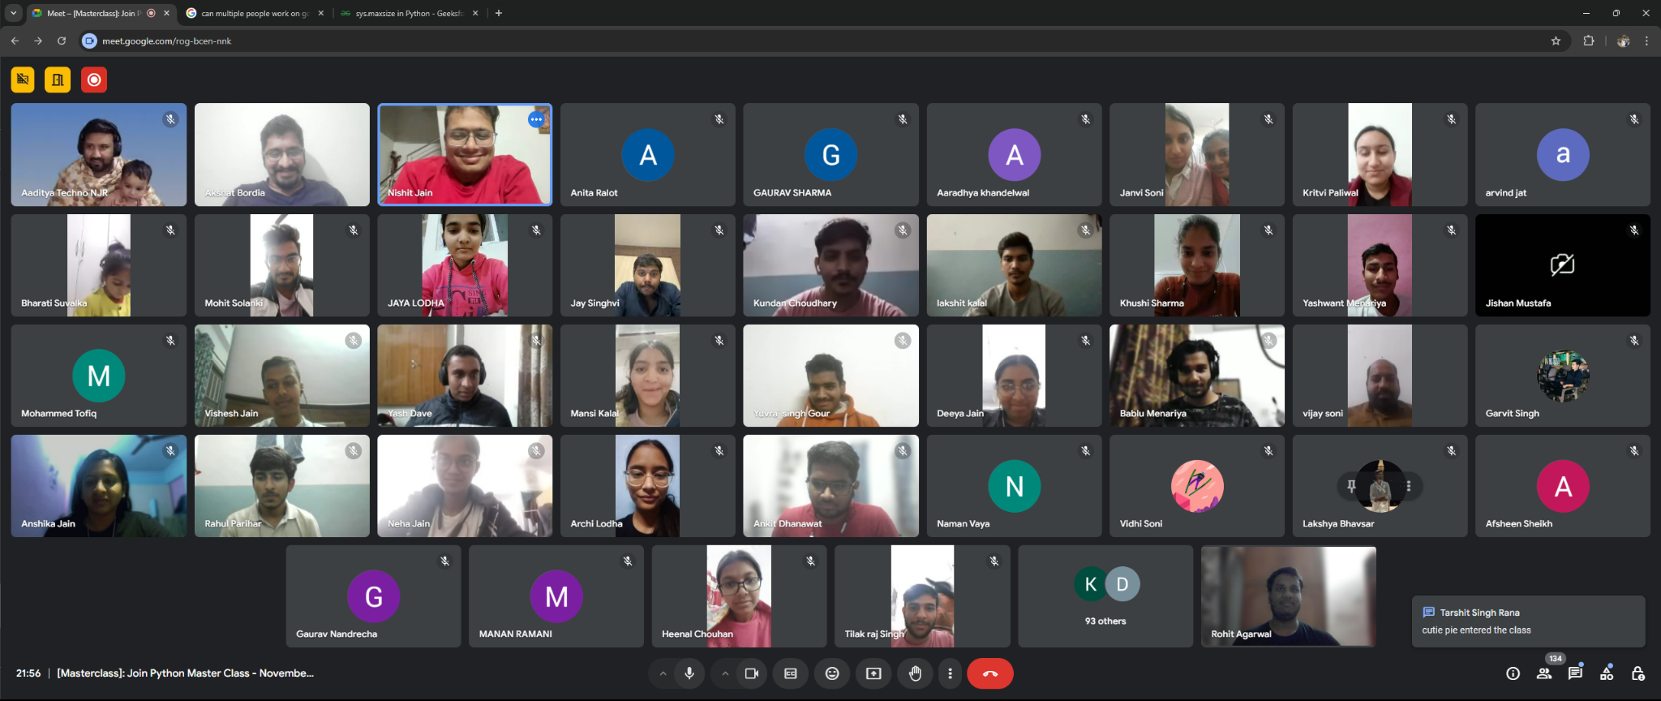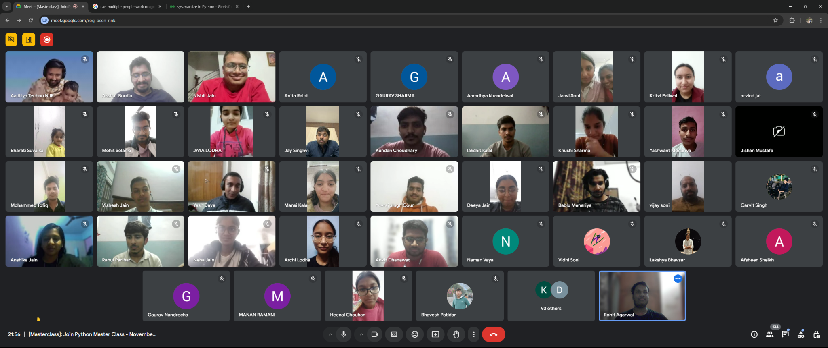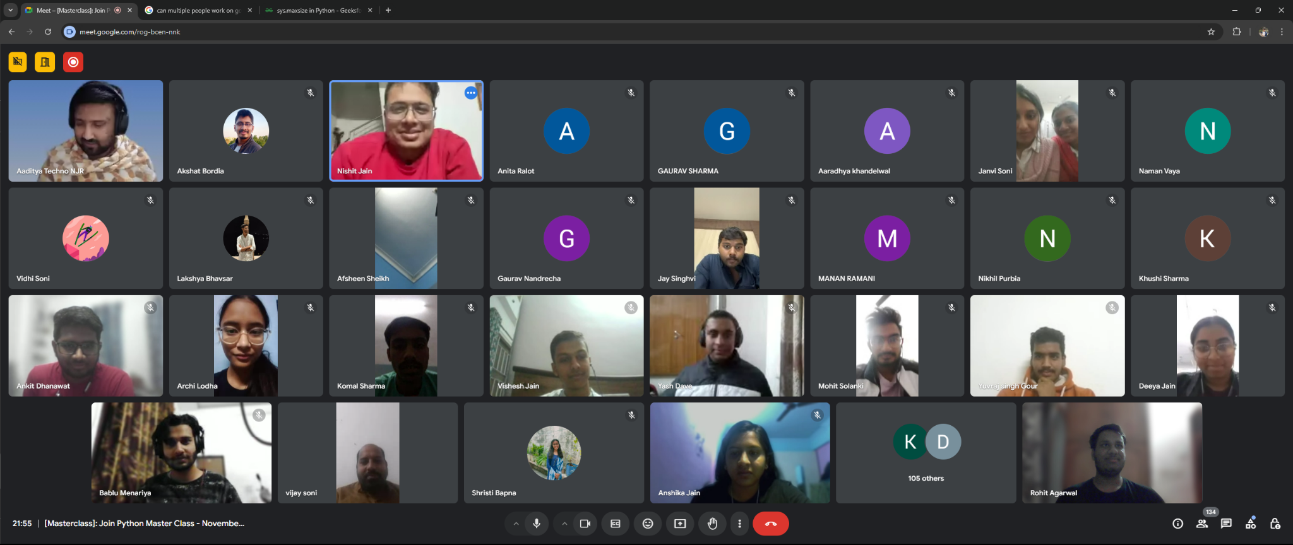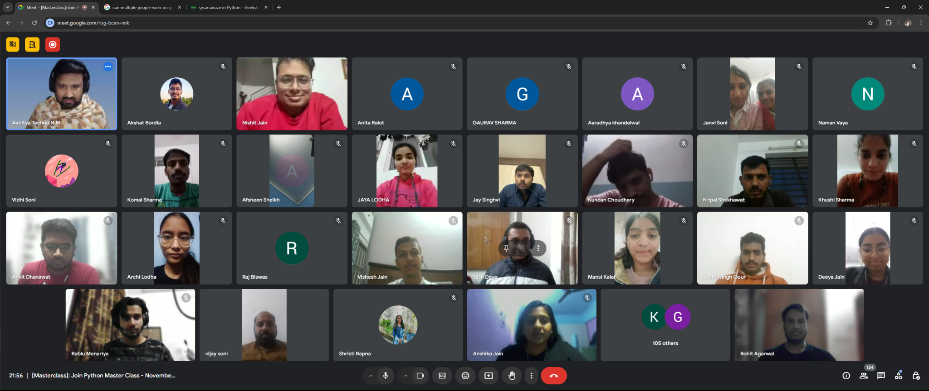

* **Day 3: Saturday, 23 November**
  + *Topics Covered*: Basics of Booleans, Conditional Statements, and Loops
  + *Highlights*: Explained logical constructs and control flow, enabling students to write decision-based code.
  + *Photos*: Students actively participated in debugging loops.

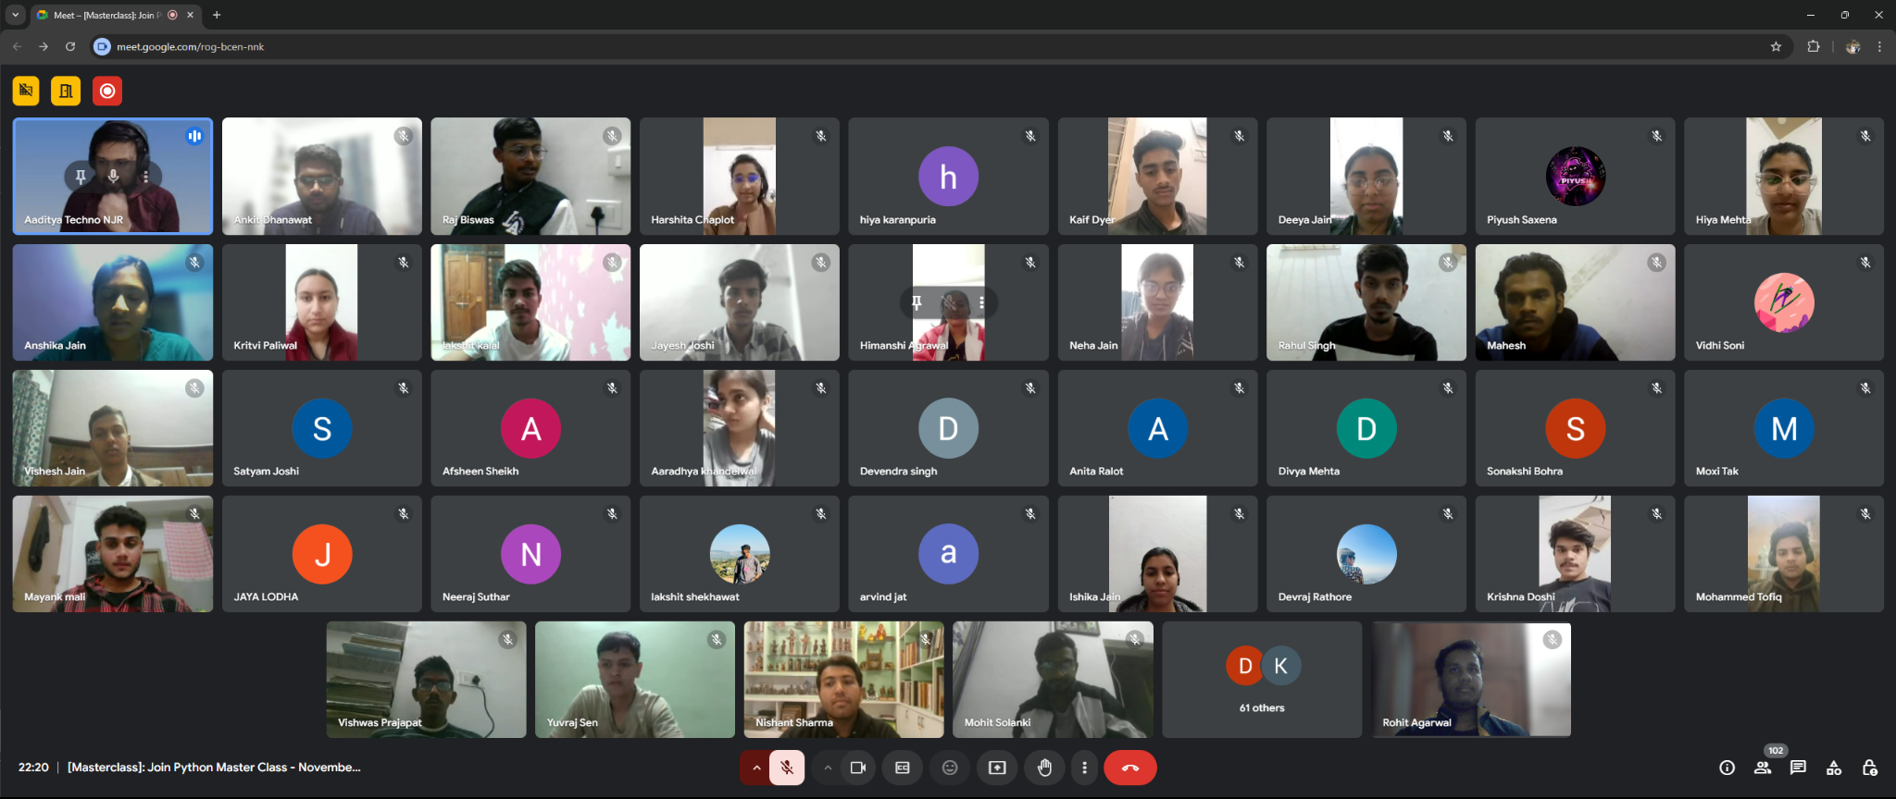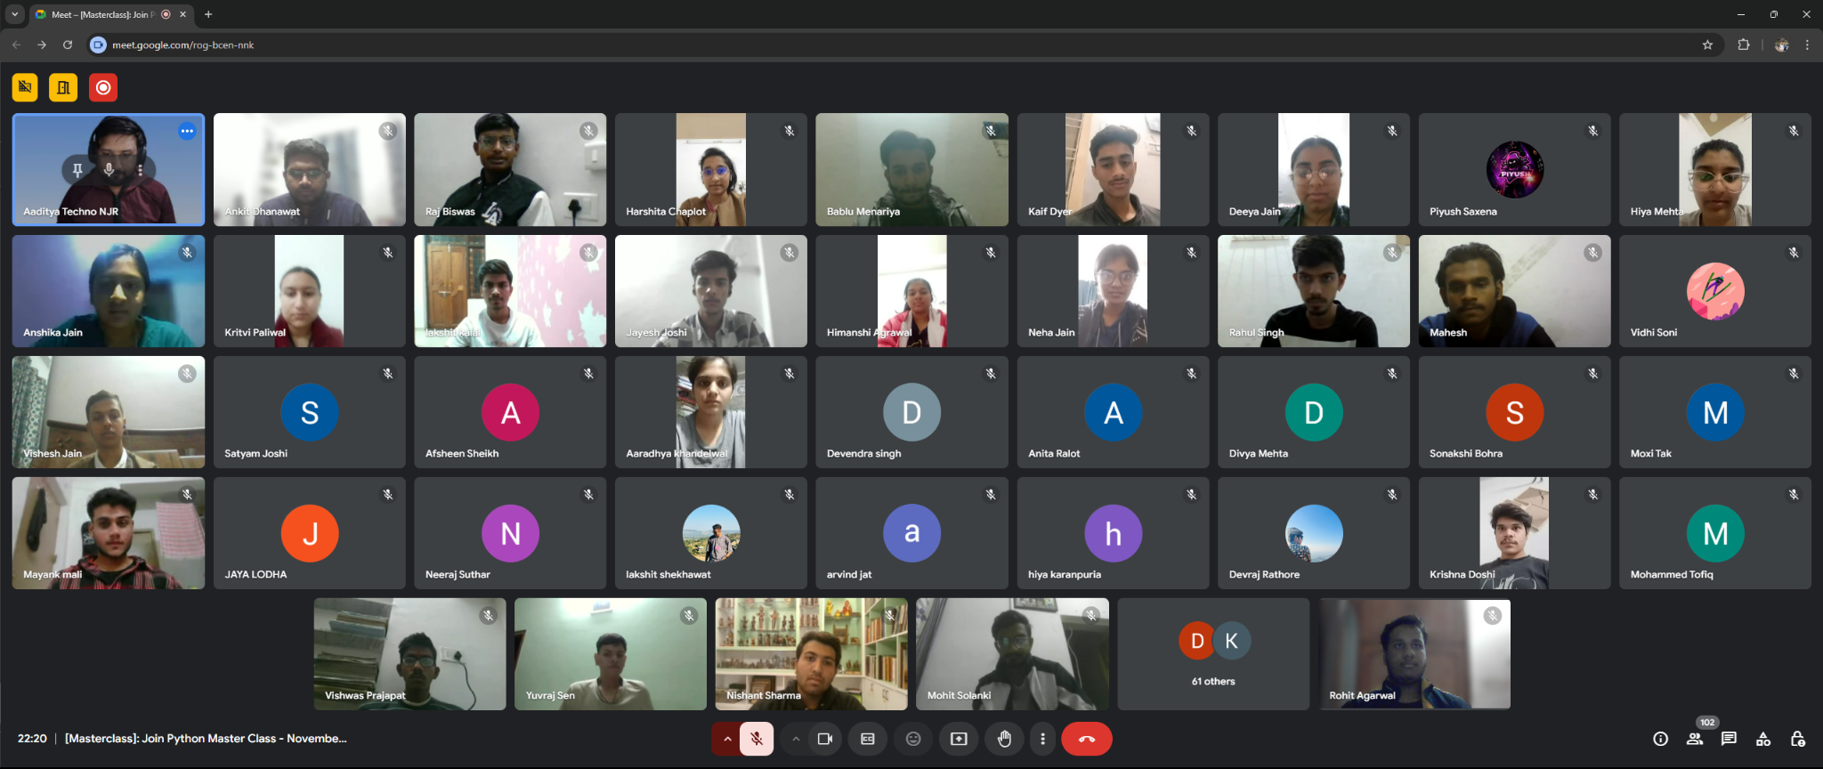

* **Day 4: Monday, 25 November**
  + *Topics Covered*: Advanced loops, Nested Loops, and Nested Conditional Statements
  + *Highlights*: Explored complex control structures and their applications in solving real-world problems.
  + *Photos*: Several enthusiastic coding discussions were documented.

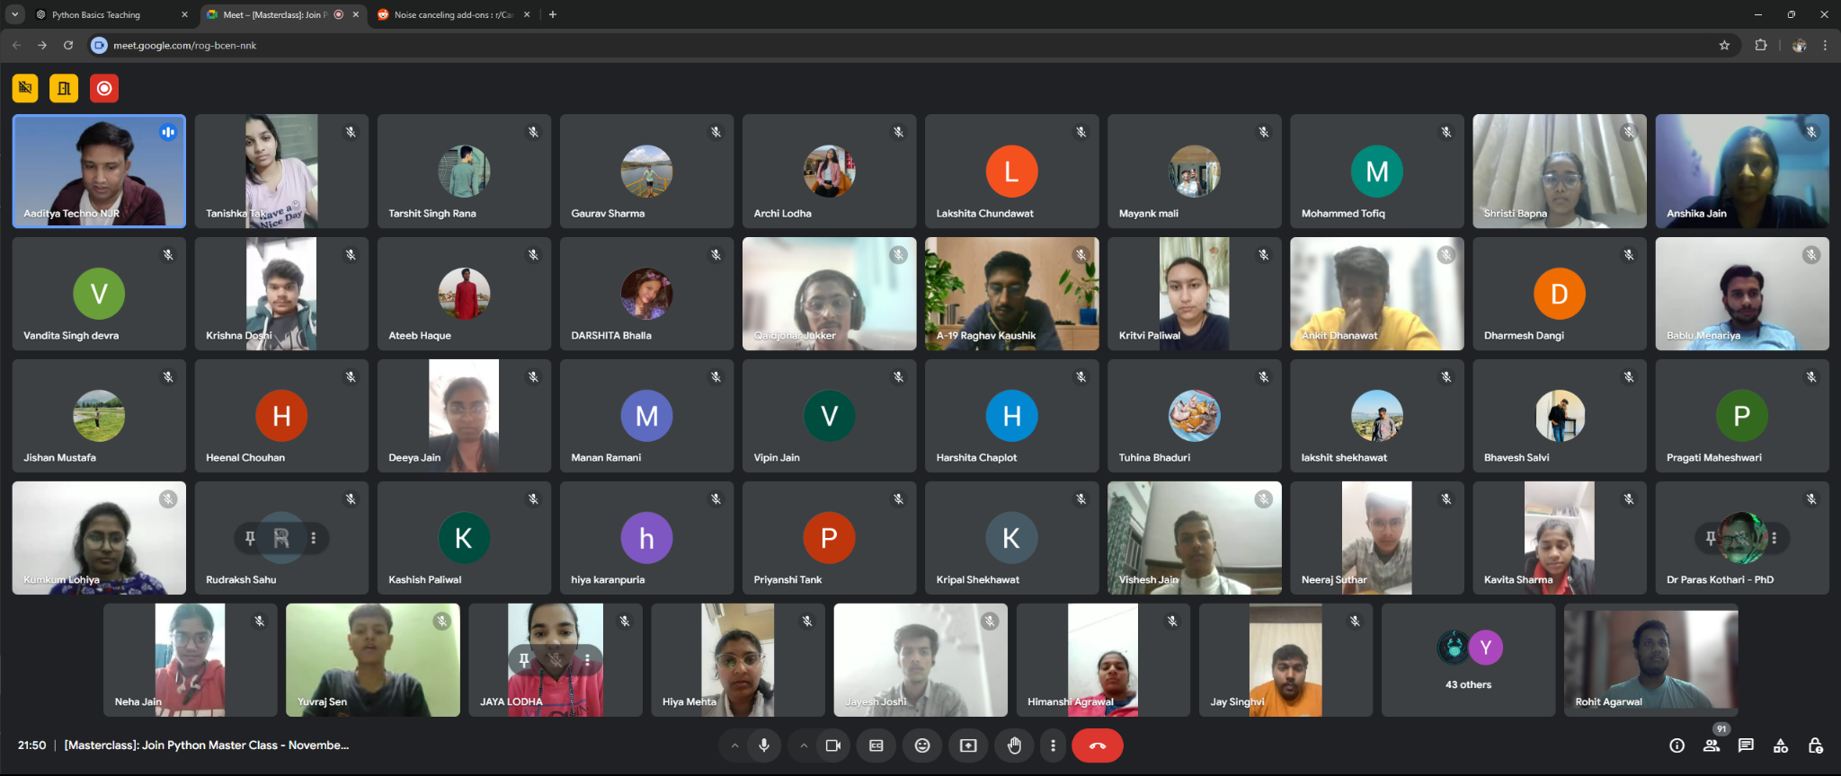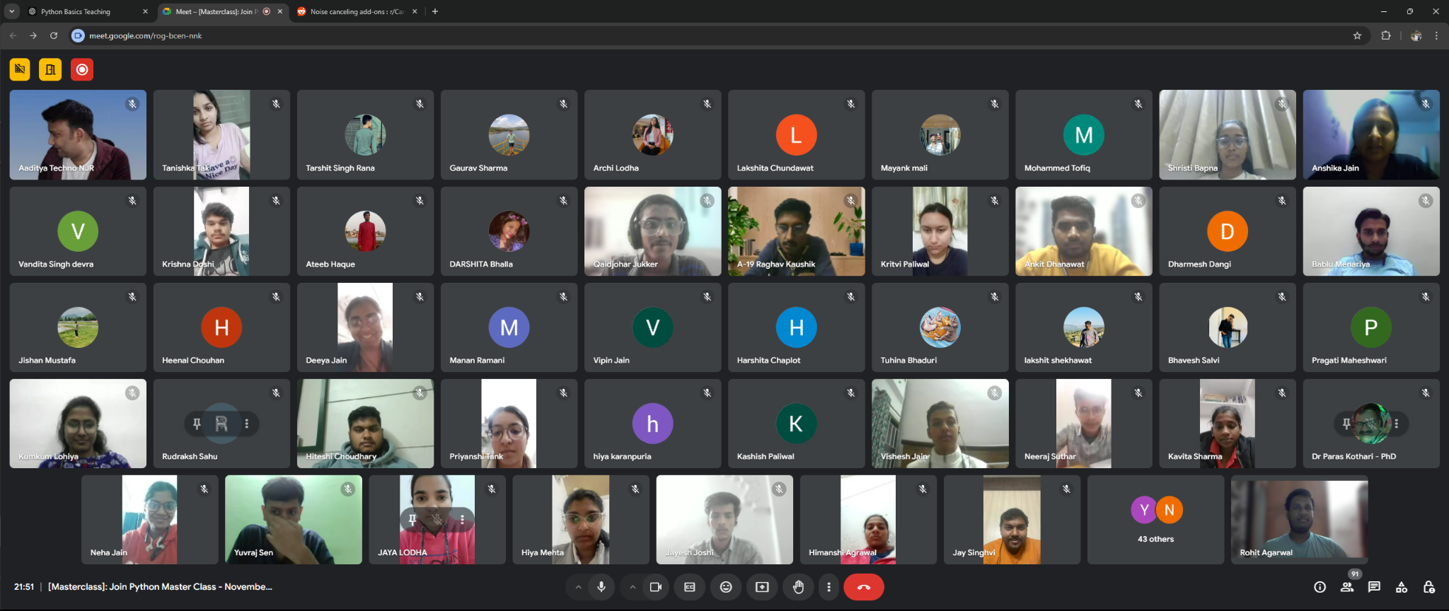

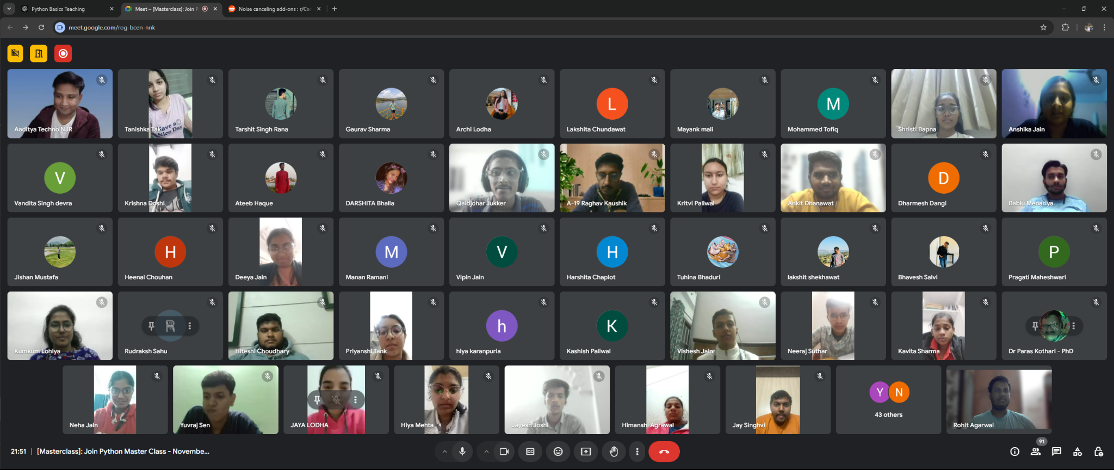

* **Day 5: Tuesday, 26 November**
  + *Topics Covered*: Tuples, Lists, and Dictionaries
  + *Highlights*: Discussed Python’s data structures, emphasizing practical use cases for data organization.
  + *Photos*: Students showcased collaborative problem-solving.

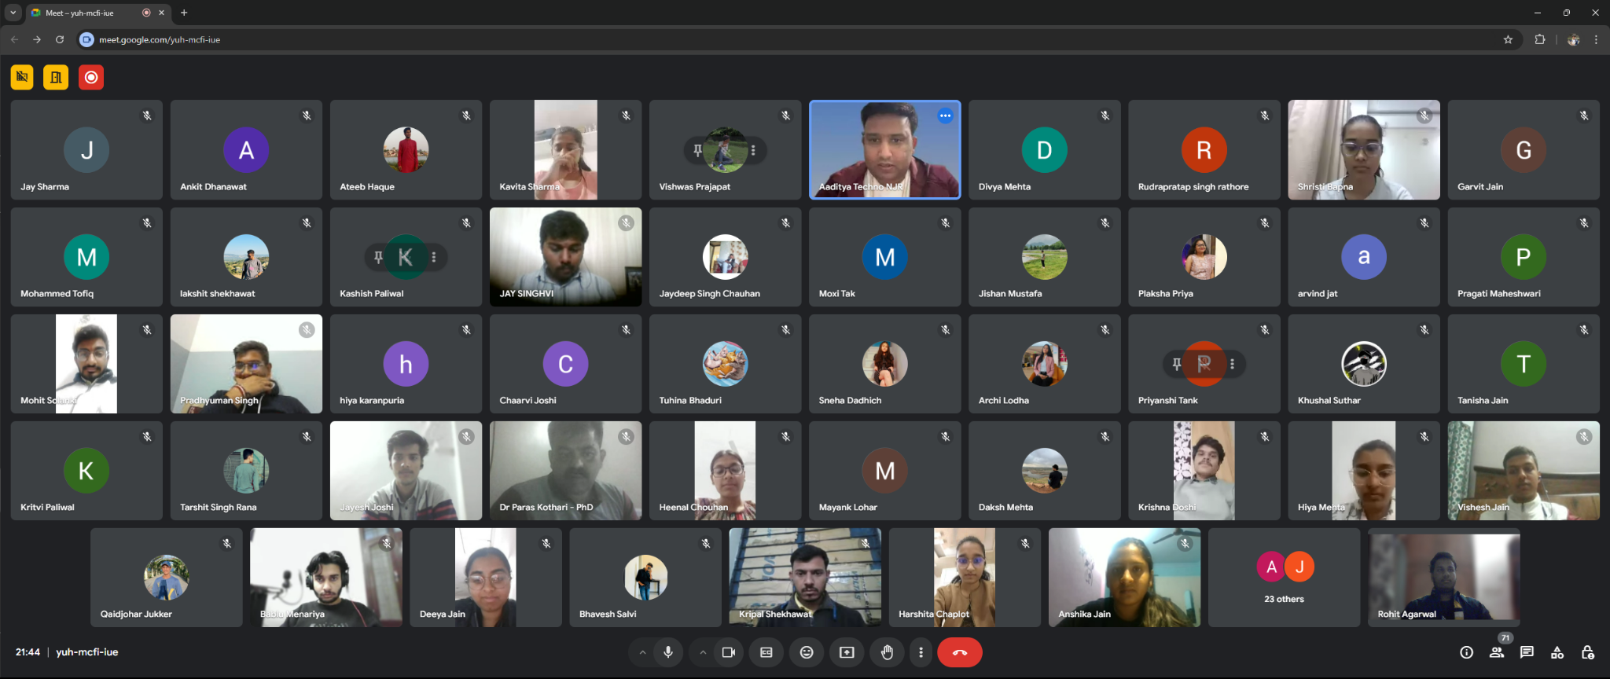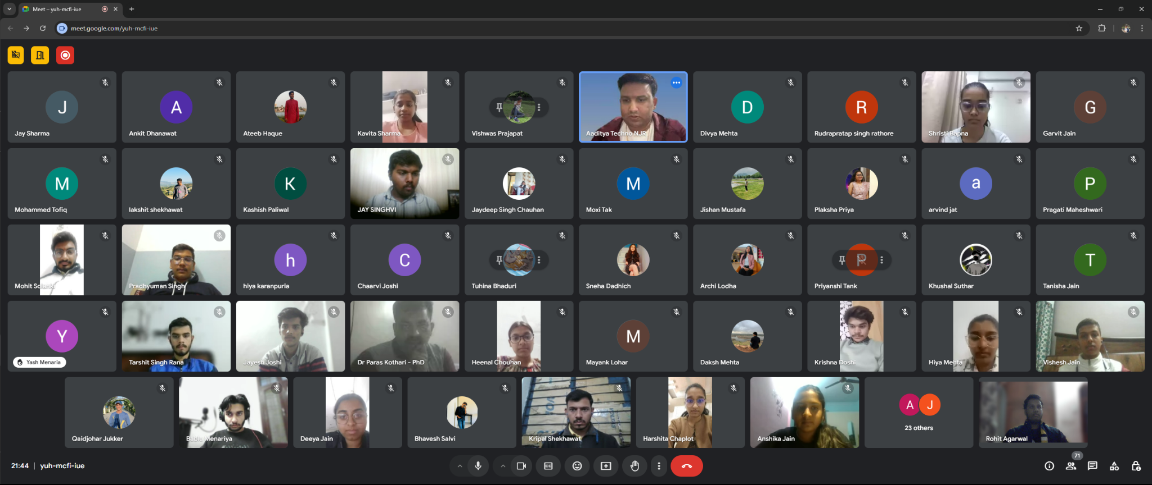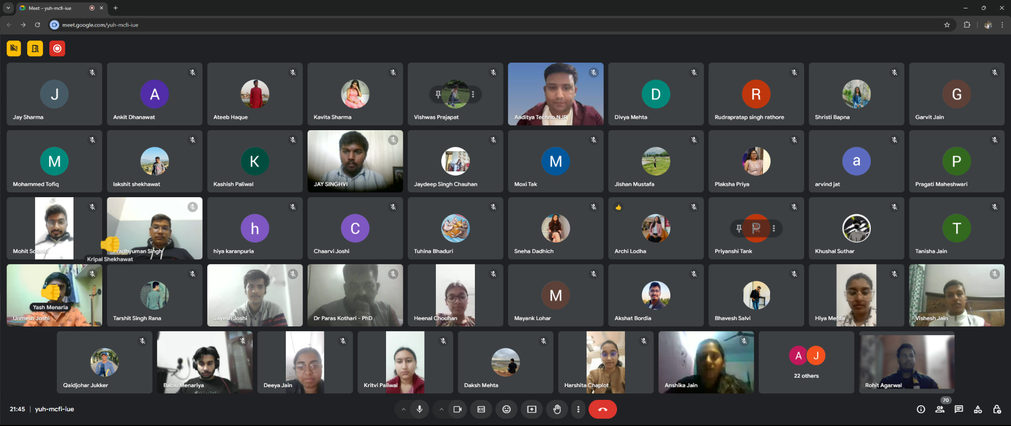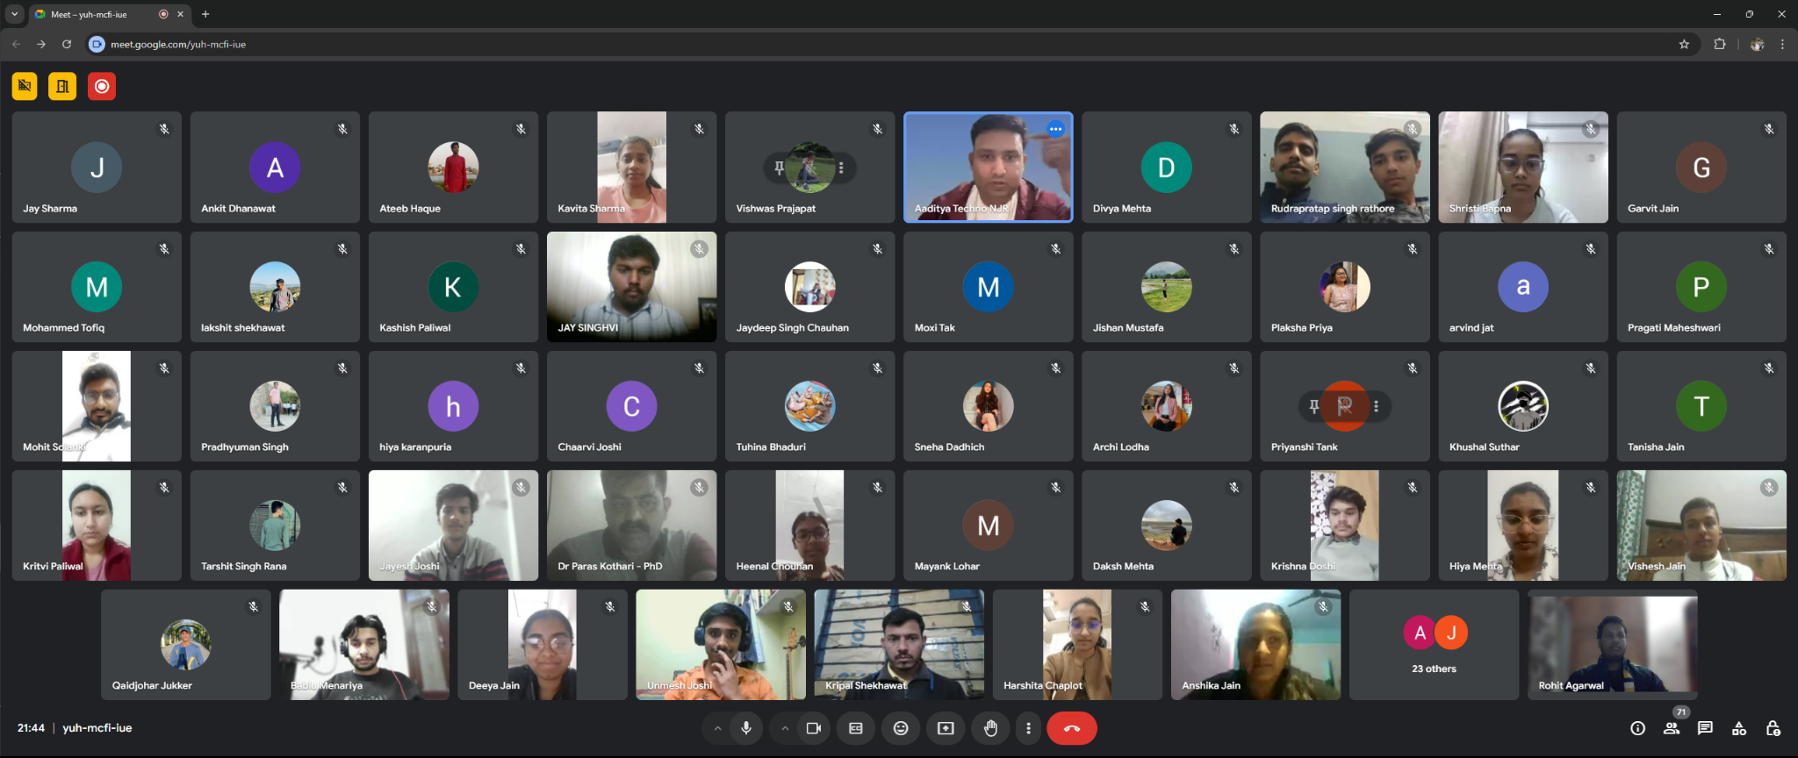

* **Day 6: Wednesday, 27 November**
  + *Topics Covered*: Functions, File Handling, and the pickle Module
  + *Highlights*: Taught the importance of modular programming, working with files, and data serialization.
  + *Photos*: Captured group photo sessions and final project showcases.

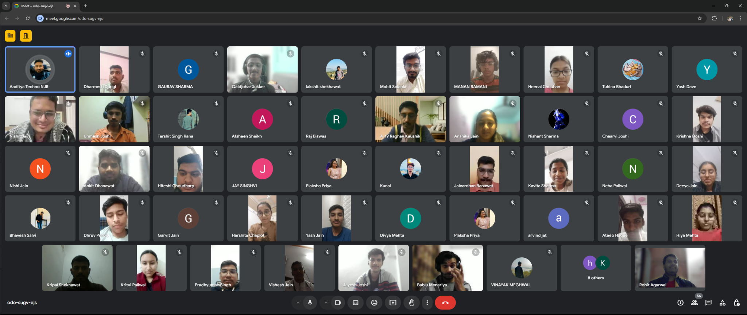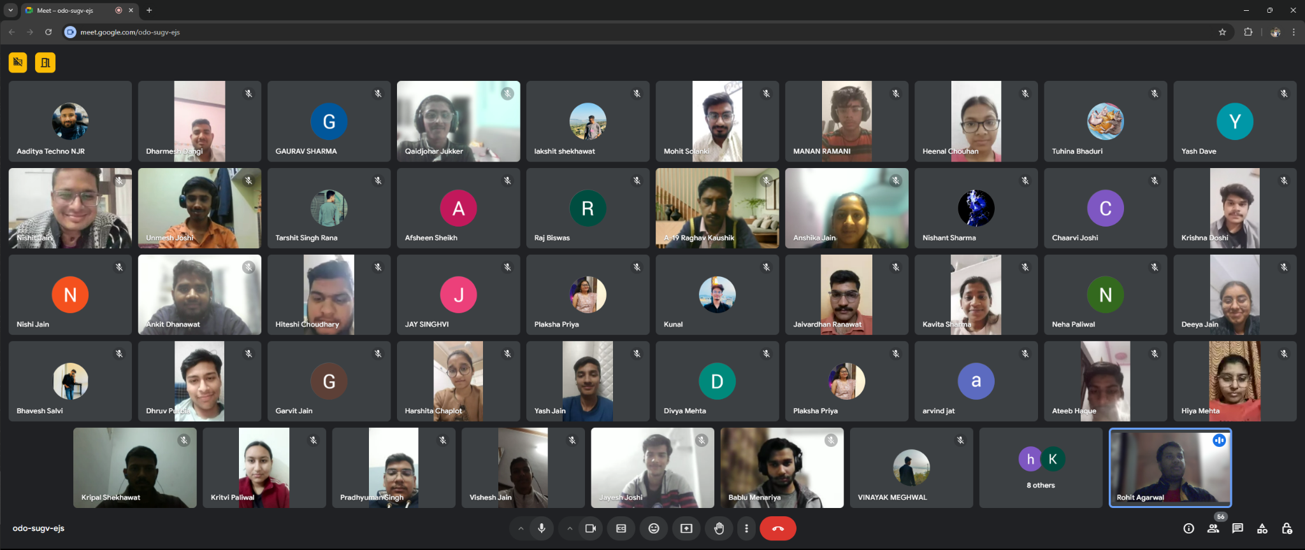

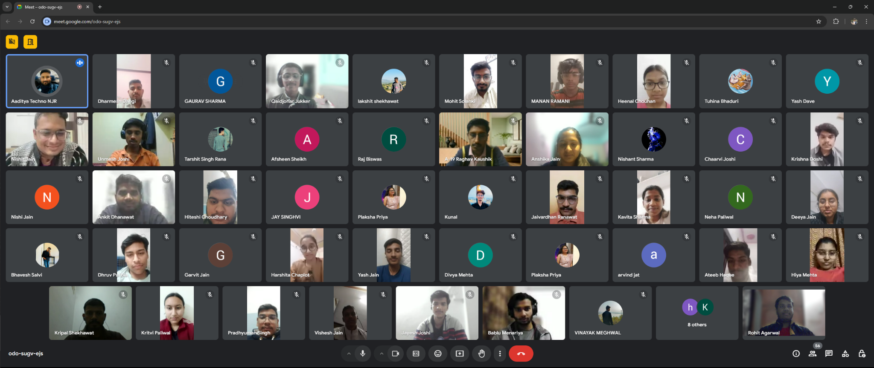

#### **Outcomes**

* Around [Insert Number] students participated enthusiastically each day.
* By the end of the masterclass, students demonstrated a significant understanding of Python fundamentals and intermediate topics.
* Many expressed their intent to pursue Python for projects and internships.

#### **Reflections**

The masterclass was an incredible experience for me as an instructor. Witnessing students' progress and their eagerness to learn reaffirmed the importance of such initiatives. The pictures captured throughout the sessions reflect their engagement and curiosity.

#### **Acknowledgments**

I would like to thank **Aaditiya Maheshwari Sir** for their support in organizing this masterclass.

#### **LINK**

* NoteBooks - <https://github.com/rohitagr0310/Python-notebooks>
* Videos - https://www.youtube.com/playlist?list=PLVMhNU0EAYrEVRtDSkXGuPaEFiM8-d_a5

#### **Team FossTech**

* **Rohit Agarwal (Lead)**
* **Anshika Jain**
* **Ankit Dhanawat**
* **Jayesh Joshi**
* **Qaidjohar Jukker**